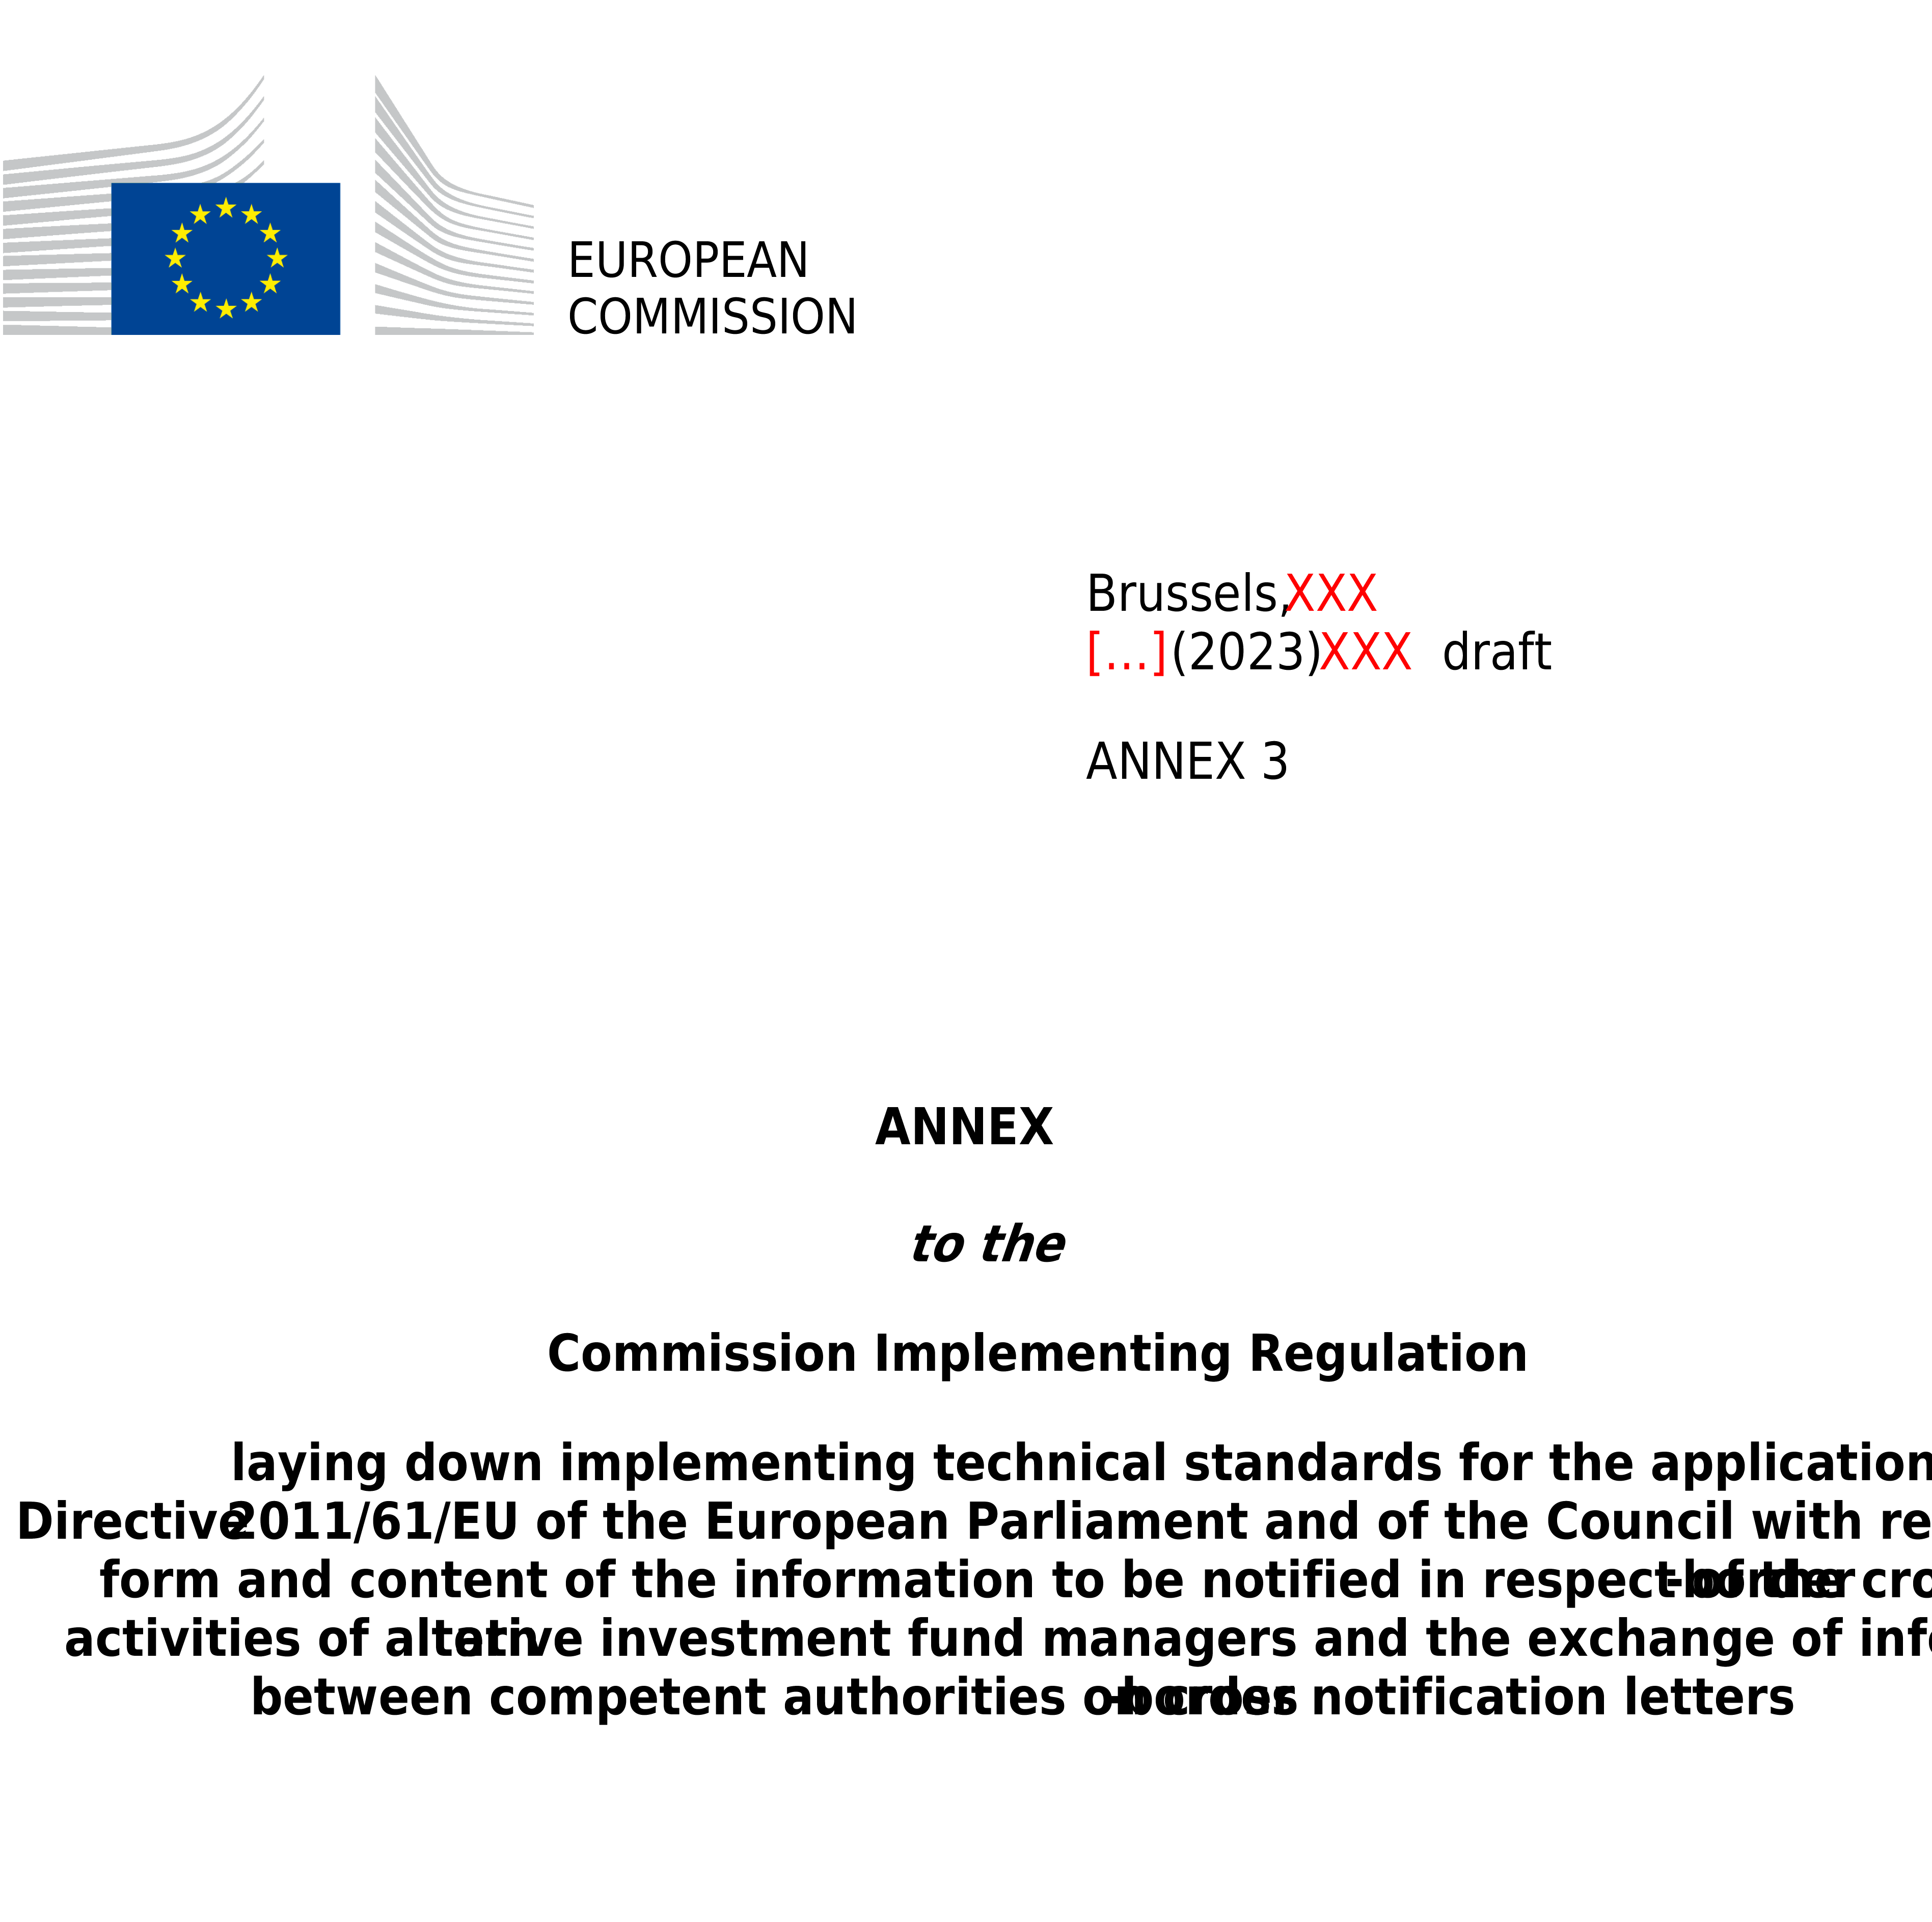

ANNEX III
Model notification letter to be submitted by an EU AIFM to the competent authority of its home Member State to manage EU AIFs established in other Member States under Article 33(2) of Directive 2011/61/EU or to establish a branch in other Member State under Article 33(3) of Directive 2011/61/EU

NOTIFICATION LETTER

NOTIFICATION OF THE INTENTION OF AN AIFM TO MANAGE AIFs ESTABLISHED IN A MEMBER STATE OTHER THAN ITS HOME MEMBER STATE IN ACCORDANCE WITH ARTICLE 33(2) OF DIRECTIVE 2011/61/EU OR TO ESTABLISH A BRANCH IN ACCORDANCE WITH ARTICLE 33(3) OF DIRECTIVE 2011/61/EU.

IN ______________________________________
(The host Member State(s))

Are you notifying amendments to information already provided in an initial notification? Yes ☐ No ☐

In case the answer to this question is ‘Yes’, please fill-in only the updated information compared to the previous notification.

Table of contents

PART 1 Information on the AIFM
PART 2 Information to be notified pursuant to Article 33(2) of Directive 2011/61/EU
Section 1. Programme of operations
Section 2. Information on the AIFs to be managed in the host Member State
PART 3 Information to be provided by the AIFM pursuant to Article 33(3) of Directive 2011/61/EU to carry out its activities in the host Member State(s) through a branch
Section 1. Information on the branch
Section 2. Programme of operations of the branch
Section 3. Operational structure of the branch
Section 4. Termination of the branch

PART 1
Information on the AIFM

Information on the AIFM
AIFM
AIFM LEI¹
National identification code of the AIFM (where available)¹
AIFM’s home Member State¹
Address and, where different from address, registered office/domicile
Duration of the AIFM (where applicable)
Details of AIFM’s website

Contact details of the department (or contact point) responsible for the notification letter within the AIFM
Department (or contact point)
Telephone number
Email address

Details of the third party (where the AIFM or internally managed AIF designates a third party to make the notification)
Third party
Address and, where different from address, registered office / domicile
Department (or contact point)
Telephone number
Email address

Contact point for the transmission of the invoice or for the communication of any applicable regulatory fee or charges (if applicable)
Name of the entity
Address and, where different from address, registered office/domicile
Department (or contact point)
Telephone number
Email address

Please specify which email address among that specified in this section (contact point at the AIFM, contact point within the appointed third party or contact point for the transmission of the invoice) is the preferred address to which the host NCA can transmit the confidential information (inter alia, login and password to access the national systems for reporting)

PART 2

Information to be notified pursuant to Article 33(2) of Directive 2011/61/EU

Section 1. Programme of operations
Please indicate the scope of activities of the AIFM in the host Member State

Investment management
☐ Portfolio management
☐ Risk management

Administration
☐ Legal and fund management accounting services
☐ Customer inquiries
☐ Valuation and pricing, including tax returns
☐ Regulatory compliance monitoring
☐ Maintenance of unit-/shareholder register
☐ Distribution of income
☐ Unit/shares issues and redemptions
☐ Contract settlements, including certificate dispatch
☐ Record keeping

☐ Marketing

Investment and non-core services
☐ Management of portfolios of investments, including those owned by pension funds and institutions for occupational retirement provision in accordance with Article 32 of Directive (EU) 2016/2341, in accordance with mandates given by investors on a discretionary, client-by-client basis
☐ Investment advice
☐ Safe-keeping and administration in relation to shares or units of collective investment undertakings
☐ Reception and transmission of orders in relation to financial instruments

Description of the strategy of the AIFM in the host Member State (e.g., indication of the volume of business envisaged, types of investors with which the AIFM will be dealing and how the AIFM will obtain and deal with those investors)

Summary details of controls over delegation arrangements with third parties in connection with the activities carried out in the host Member State

Section 2. Information on the AIFs to be managed in the host Member State
Please fill the table below with any information available on existing AIFs that the AIFM intends to manage in the host Member State. Where an AIF takes the form of an umbrella AIF with several compartments or sub-funds, references to the AIF in the table below shall be understood as referring to the compartment or sub-fund to be managed in the host Member State and not to the umbrella AIF, which shall be identified separately in the corresponding column.

Name of the AIF  to be managed in the  host Member State | Date of incorporation or constitution  (where applicable) | Legal form of the AIF | LEI of the AIF  (where available) | Name of the depositary of the AIF | Duration of the AIF | AIF’s national identification code  (where available) | Name of the umbrella AIF  (where applicable) | AIF’s investment strategy

Master-feeder structures (if applicable):
Name of the master AIF or compartment(s) | LEI of the master AIF or compartment(s) (where available) | AIFM of the master AIF / compartment (where different from the AIF’s AIFM) | LEI AIFM of the master AIF / compartment (where different from the AIF’s AIFM and where available) | Home Member State of the master AIF (where different from the AIF’s home Member State) | Home Member State of the AIFM (where different from the master AIF’s home Member State)

PART 3

Information to be provided by the AIFM pursuant to Article 33(3) of Directive 2011/61/EU to carry out its activities in the host Member State(s) through a branch
This Part must be filled only where the AIFM intends to establish a branch in the host Member State. Where the AIFM intends to carry out its activities in the host Member State exclusively under the freedom to provide services, this Part shall be left blank.

Section 1. Information on the branch
Identification of the branch
Name of the branch
Home State national identification code of the branch (where available)⁵
Host State national identification code of the branch (where available)⁵
Address and, where different from address, registered office/domicile⁵
Details of the branch’s website (where different from the AIFM’s website)

Department (or contact point) from which documents may be obtained in the home Member State where the branch is established
Department (or contact point)
Address and, where different from address, registered office/domicile
Telephone number
Email address

Section 2. Programme of operations of the branch
The branch will carry out the following activities and provide the following services in the host Member State(s):

Investment management
☐ Portfolio management
☐ Risk management

Administration
☐ Legal and fund management accounting services
☐ Customer inquiries
☐ Valuation and pricing, including tax returns
☐ Regulatory compliance monitoring
☐ Maintenance of unit-/shareholder register
☐ Distribution of income
☐ Unit/shares issues and redemptions
☐ Contract settlements, including certificate dispatch
☐ Record keeping

☐ Marketing

Investment and non-core services
☐ Management of portfolios of investments, including those owned by pension funds and institutions for occupational retirement provision in accordance with Article 32 of Directive (EU) 2016/2341, in accordance with mandates given by investors on a discretionary, client-by-client basis
☐ Investment advice
☐ Safe-keeping and administration in relation to shares or units of collective investment undertakings
☐ Reception and transmission of orders in relation to financial instruments

Section 3. Operational structure of the branch

Description of the risk management process put in place by the AIFM at the level of the branch based on Article 45 of the Commission Delegated Regulation (EU) No 231/2013

Description of the functional, geographical, and legal reporting

Description of the place of the branch into the corporate structure of the AIFM, or of the group where the AIFM is a member of a group

Description of the rules in place for reporting by the branch to the head office of the AIFM

Summary of the systems and controls in place at the level of the branch as set out in Article 2(3)(d) of Commission Delegated Regulation (EU) .../... ([reference to the RTS to be included when published])

Description of the controls over delegation arrangements with respect to activities carried out in the host Member State

Description of the arrangements for the compliance with the obligations that fall under the responsibility of the competent authority of the host Member State in which the branch is established according to Article 45(2) of Directive 2011/61/EU

Description of the procedures put in place, and the human and material resources allocated, to comply with anti-money laundering and counter financing of terrorism obligations

Please provide forecast statements for both profit and loss and cash flow over an initial 36-month period

Section 4. Termination of the branch
This section should not be filled in an initial notification. It should be filled only in the event of an update, where the termination of the branch initially notified is envisaged.
Details and processes for winding down the business operations, including details of the measures to protect the interests of investors in the host Member State, how complaints are resolved and the discharge of any outstanding liabilities

Schedule of the planned termination

Date
Name and capacity of the signatory
Signature

This field should always be filled-in, also in the case of updates.
Please indicate a single contact point for the transmission of the invoice or for the communication of any applicable regulatory fee or charge referred to in Article 9 of Regulation (EU) 2019/1156 and in Article 2 of Commission Implementing Regulation (EU) 2021/955. That contact point may be the same as the contact point designated within the management company, or a contact point within an appointed third party.
The legal form is one of the following: common fund, unit trust, investment company, or any other legal form available under the national legislation of the AIF home Member State.
Please specify the predominant AIF type and the breakdown by investment strategies as set out in the reporting template included in Annex IV of Commission Delegated Regulation (EU) 231/2013.
This field should always be filled-in, also in the case of updates, where information concerning the branch is provided.

