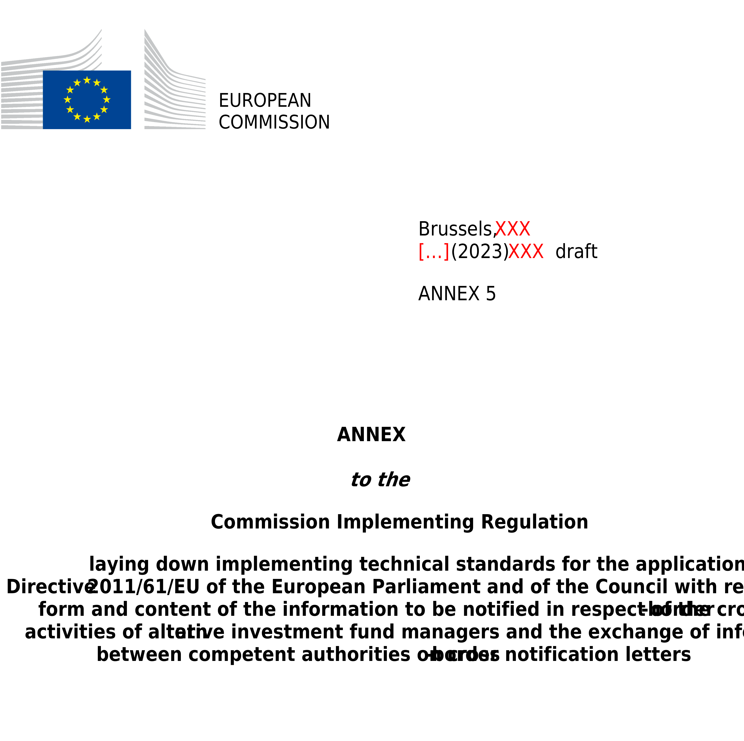

ANNEX V
Model notification letter regarding persons responsible for a branch to be submitted by EU AIFM to the competent authority of its home Member State intending to establish a branch in other Member States under Article 33(3), letter (c), of Directive 2011/61/EU

NOTIFICATION LETTER

NOTIFICATION OF PERSONS RESPONSIBLE FOR A BRANCH RELATED TO THE INTENTION OF AN AIFM TO ESTABLISH A BRANCH IN A MEMBER STATE OTHER THAN ITS HOME MEMBER STATE IN ACCORDANCE WITH ARTICLE 33, PARAGRAPH (3), LETTER (C), OF DIRECTIVE 2011/61/EU.

IN ______________________________________
(the host Member State)

Identification of the AIFM
AIFM
AIFM LEI
National identification code of the AIFM (where available)
AIFM’s home Member State
Address and, where different from address, registered office/domicile

Identification of the branch
Name of the branch
Home State national identification code of the branch (where available)
Host State national identification code of the branch (where available)
Address and, where different from address, registered office/domicile

Are you notifying amendments to information already provided in an initial notification? Yes ☐ No ☐

In case the answer to this question is ‘Yes’, please highlight below the updated information compared to the previous notification.

NOTIFICATION OF A PERSON RESPONSIBLE FOR:

☐ The management of the branch
☐ The termination of the operations of the branch

Identification of notified person and contact details
Surname
First name
Position or function performed
Start date for this position
End date for this position (where relevant)
Telephone number
Email address

Additional remarks
Additional remarks, where indicated (e.g. former name in case of name changes, position changes etc.)

Date
Signature of notified person

Date
Name and capacity of the signatory for the AIFM / branch
Signature

Please submit one separate form for each relevant person and one form per electronic file only.
Notification of a person responsible for the termination of a branch should only be filled as an update where the termination of the branch is envisaged.
Should not be identical with notified person.

